Experiment:5A

CODE:
clc;
clear;
close all;

%% EXPERIMENT 5(A): IMPEDANCE MATCHING NETWORK

% Given parameters
Z0 = 50;
ZL = 75 + 1j*25;
f0 = 10e9;

% Frequency sweep
f = linspace(8e9,12e9,1001);
c = 3e8;
lambda = c/f0;

% Initial reflection coefficient
GammaL = (ZL-Z0)/(ZL+Z0);
Gamma_mag = abs(GammaL);

% Return loss and VSWR
RL_before = -20*log10(Gamma_mag);
VSWR = (1+Gamma_mag)/(1-Gamma_mag);

fprintf('IMPEDANCE MATCHING RESULTS\n');
fprintf('-----------------------------\n');
fprintf('Load impedance = %.2f + j%.2f Ohm\n',real(ZL),imag(ZL));
fprintf('Reflection coefficient = %.4f\n',Gamma_mag);
fprintf('Return loss before matching = %.4f dB\n',RL_before);
fprintf('VSWR = %.4f\n',VSWR);

%% Single shunt open-circuit stub design

% Normalized load admittance
yL = Z0/ZL;

% Calculate possible stub positions
t1 = 1-sqrt(3);
t2 = 1+sqrt(3);

d1 = mod(atan(t1),pi)*lambda/(2*pi);
d2 = mod(atan(t2),pi)*lambda/(2*pi);

% Calculate normalized admittance at stub position
y1 = (yL+1j*t1)/(1+1j*yL*t1);
y2 = (yL+1j*t2)/(1+1j*yL*t2);

% Open-circuit stub lengths
l1 = mod(atan(-imag(y1)),pi)*lambda/(2*pi);
l2 = mod(atan(-imag(y2)),pi)*lambda/(2*pi);

% Select first solution
d = d1;
l = l1;

fprintf('\nMATCHING STUB DIMENSIONS\n');
fprintf('Distance to stub = %.4f mm\n',d*1000);
fprintf('Open stub length = %.4f mm\n',l*1000);

%% Frequency-dependent matching network

beta = 2*pi*f/c;

Gamma = zeros(size(f));
Zin = zeros(size(f));

for k = 1:length(f)

% Load normalized admittance
yload = Z0/ZL;

% Transmission line admittance
td = tan(beta(k)*d);

yin = (yload+1j*td)/(1+1j*yload*td);

% Open circuit stub admittance
ystub = 1j*tan(beta(k)*l);

% Total normalized admittance
ytotal = yin+ystub;

% Input impedance
Zin(k) = Z0/ytotal;

% Input reflection coefficient
Gamma(k) = (Zin(k)-Z0)/(Zin(k)+Z0);

end

% Return loss after matching
RL_after = -20*log10(max(abs(Gamma),1e-12));

% Results at 10 GHz
[~,idx] = min(abs(f-f0));

fprintf('\nRESULTS AFTER MATCHING AT 10 GHz\n');
fprintf('Input impedance = %.4f + j%.4f Ohm\n',...
real(Zin(idx)),imag(Zin(idx)));

fprintf('Reflection coefficient = %.6f\n',abs(Gamma(idx)));
fprintf('Return loss = %.4f dB\n',RL_after(idx));

%% Plot 1: Reflection coefficient

figure;
plot(f/1e9,abs(Gamma),'LineWidth',2);
grid on;
xlabel('Frequency (GHz)');
ylabel('|S11|');
title('Impedance Matching - Reflection Coefficient');

%% Plot 2: Return loss

figure;
plot(f/1e9,RL_after,'LineWidth',2);
grid on;
xlabel('Frequency (GHz)');
ylabel('Return Loss (dB)');
title('Impedance Matching - Return Loss');

%% Plot 3: Input impedance

figure;
plot(f/1e9,real(Zin),'LineWidth',2);
hold on;
plot(f/1e9,imag(Zin),'LineWidth',2);
grid on;
xlabel('Frequency (GHz)');
ylabel('Impedance (Ohm)');
legend('Real(Zin)','Imaginary(Zin)');
title('Input Impedance After Matching');

%% Plot 4: Smith Chart (if available)

figure;
smithplot(Gamma);
title('Smith Chart - Matched Network');

OUTPUT:

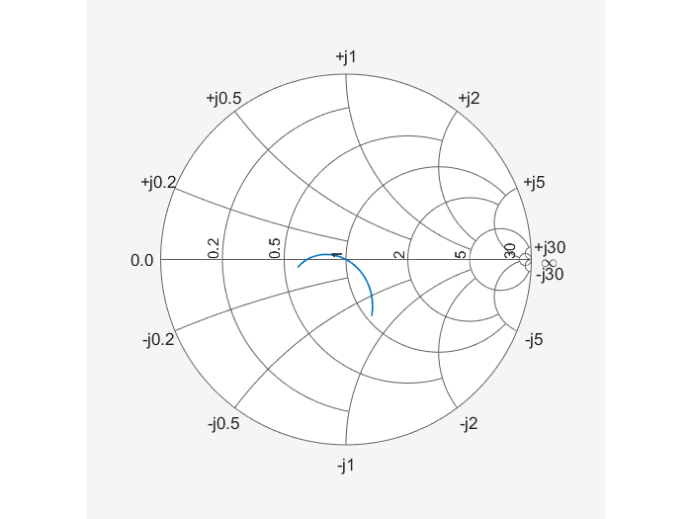

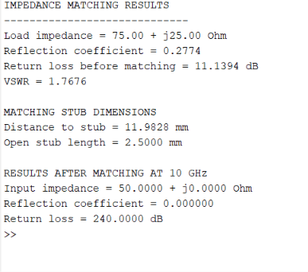

Experiment:5B

CODE:

clc;
clear;
close all;

%% EXPERIMENT 5(B): MICROWAVE LOW-PASS FILTER DESIGN

% Design specifications
Z0 = 50;
fc = 10e9;
fstart = 8e9;
fstop = 12e9;

% Frequency sweep
f = linspace(fstart,fstop,1001);
w = 2*pi*f;
wc = 2*pi*fc;

%% Third-order Butterworth filter

N = 3;

% Butterworth prototype values
g1 = 1;
g2 = 2;
g3 = 1;

% Calculate filter components
L1 = (Z0*g1)/wc;
C2 = g2/(Z0*wc);
L3 = (Z0*g3)/wc;

fprintf('MICROWAVE FILTER DESIGN RESULTS\n');
fprintf('--------------------------------\n');

fprintf('Filter type = 3rd Order Butterworth Low Pass\n');
fprintf('Cutoff frequency = %.2f GHz\n',fc/1e9);
fprintf('Characteristic impedance = %.2f Ohm\n',Z0);

fprintf('\nFILTER COMPONENT VALUES\n');
fprintf('L1 = %.4f nH\n',L1*1e9);
fprintf('C2 = %.4f pF\n',C2*1e12);
fprintf('L3 = %.4f nH\n',L3*1e9);

%% Calculate S11 and S21 using ABCD matrices

S11 = zeros(size(f));
S21 = zeros(size(f));

for k = 1:length(f)

omega = w(k);

% Series inductor L1
Z1 = 1j*omega*L1;
A1 = [1 Z1; 0 1];

% Shunt capacitor C2
Y2 = 1j*omega*C2;
A2 = [1 0; Y2 1];

% Series inductor L3
Z3 = 1j*omega*L3;
A3 = [1 Z3; 0 1];

% Total ABCD matrix
ABCD = A1*A2*A3;

A = ABCD(1,1);
B = ABCD(1,2);
C = ABCD(2,1);
D = ABCD(2,2);

denominator = A+B/Z0+C*Z0+D;

% Scattering parameters
S11(k) = (A+B/Z0-C*Z0-D)/denominator;
S21(k) = 2/denominator;

end

%% Convert S parameters into dB

S11_dB = 20*log10(max(abs(S11),1e-12));
S21_dB = 20*log10(max(abs(S21),1e-12));

% Insertion loss
IL = -S21_dB;

%% Calculate -3 dB cutoff frequency

target = -3.0103;

% Find crossing near expected cutoff
idx = find(S21_dB <= target,1,'first');

if isempty(idx)
fc_sim = NaN;
else
% Linear interpolation
if idx > 1
fc_sim = interp1( ...
S21_dB(idx-1:idx), ...
f(idx-1:idx), ...
target);
else
fc_sim = f(idx);
end
end

%% Percentage deviation

if ~isnan(fc_sim)
deviation = abs(fc_sim-fc)/fc*100;
else
deviation = NaN;
end

%% Display results

fprintf('\nSIMULATION RESULTS\n');
fprintf('--------------------------------\n');

fprintf('S21 at 10 GHz = %.4f dB\n',...
S21_dB(abs(f-fc)==min(abs(f-fc))));

fprintf('S11 at 10 GHz = %.4f dB\n',...
S11_dB(abs(f-fc)==min(abs(f-fc))));

fprintf('Insertion loss at 10 GHz = %.4f dB\n',...
IL(abs(f-fc)==min(abs(f-fc))));

fprintf('Simulated cutoff frequency = %.4f GHz\n',...
fc_sim/1e9);

fprintf('Theoretical cutoff frequency = %.4f GHz\n',...
fc/1e9);

fprintf('Percentage deviation = %.4f %%\n',...
deviation);

fprintf('Passband = Frequencies below 10 GHz\n');
fprintf('Stopband = Frequencies above 10 GHz\n');

%% Plot 1: S11 response

figure;
plot(f/1e9,S11_dB,'LineWidth',2);
grid on;
xlabel('Frequency (GHz)');
ylabel('S11 (dB)');
title('Microwave Filter - S11 Response');

%% Plot 2: S21 response

figure;
plot(f/1e9,S21_dB,'LineWidth',2);
hold on;
yline(-3.0103,'--r','-3 dB');
xline(10,'--k','10 GHz');
grid on;
xlabel('Frequency (GHz)');
ylabel('S21 (dB)');
title('Microwave Filter - S21 Response');

%% Plot 3: Insertion loss

figure;
plot(f/1e9,IL,'LineWidth',2);
grid on;
xlabel('Frequency (GHz)');
ylabel('Insertion Loss (dB)');
title('Microwave Filter - Insertion Loss');

%% Plot 4: Combined S parameter response

figure;
plot(f/1e9,S11_dB,'LineWidth',2);
hold on;
plot(f/1e9,S21_dB,'LineWidth',2);
yline(-3.0103,'--k');
grid on;
xlabel('Frequency (GHz)');
ylabel('Magnitude (dB)');
legend('S11','S21','-3 dB');
title('Frequency Selective Filter Response');



